[1] CSA-1557 CLOUD COMPUTING LAB PRACTICAL

5.Create a simple cloud software application for Mark Sheet Processing System using any Cloud Service Provider to demonstrate SaaS include the necessary fields such as name of the student, Reg no of the student, Subjects , Marks, Average, percentage, rank, overall performance etc.

STEP-1:

Login into zoho.com and create an account.Then go to zoho creator and create a new application starting with a new form.Add or insert the required fields.

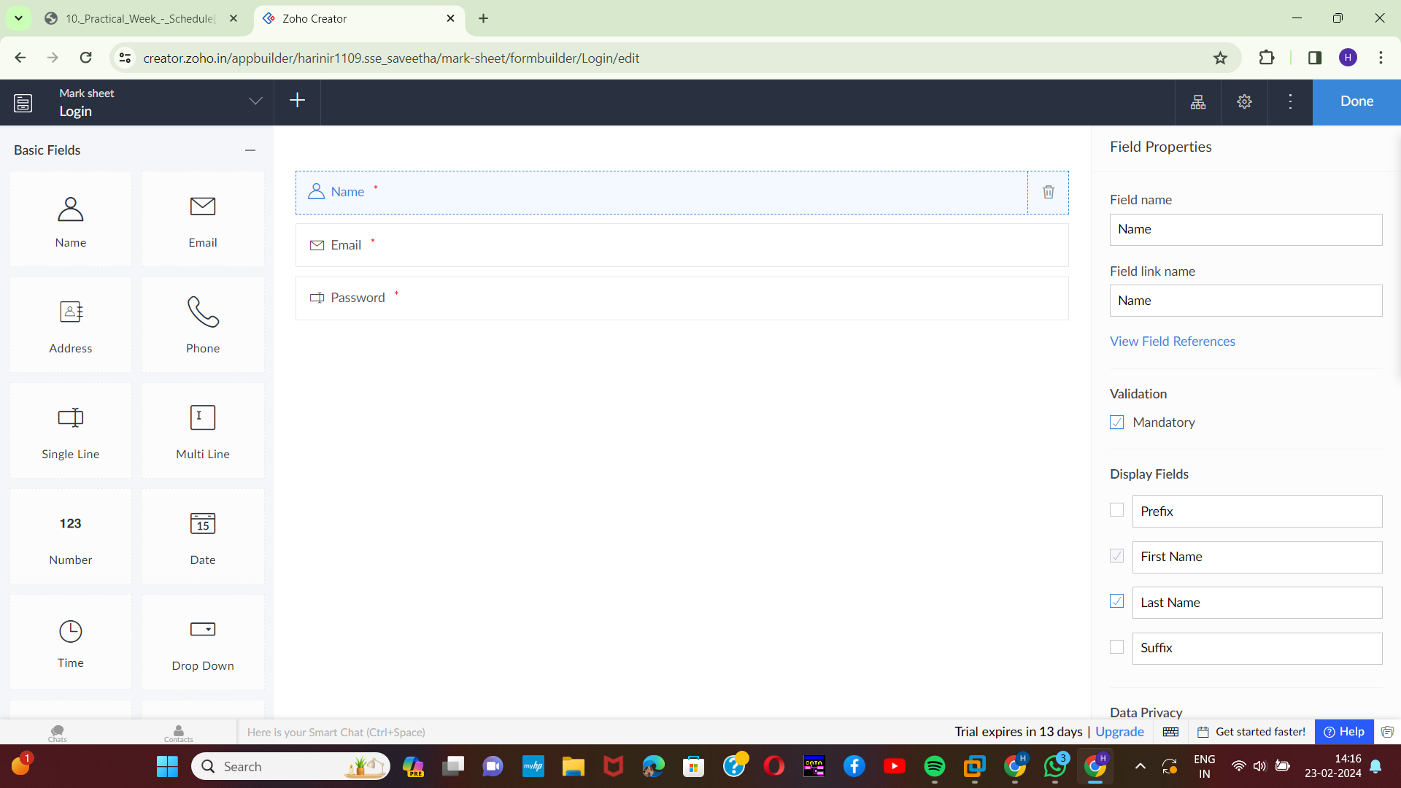

STEP-2:

Execute or run the model and get the required login form in live.

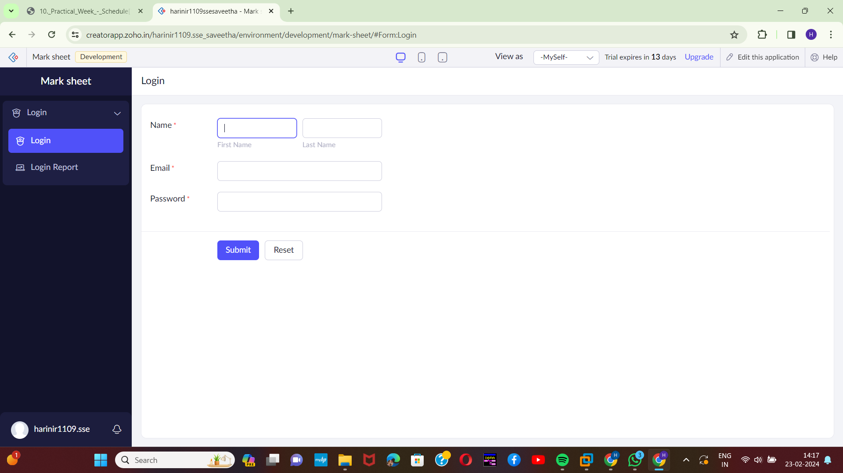[2]

STEP-3:

Next step is to add another form which consists of assessment details with the fields.

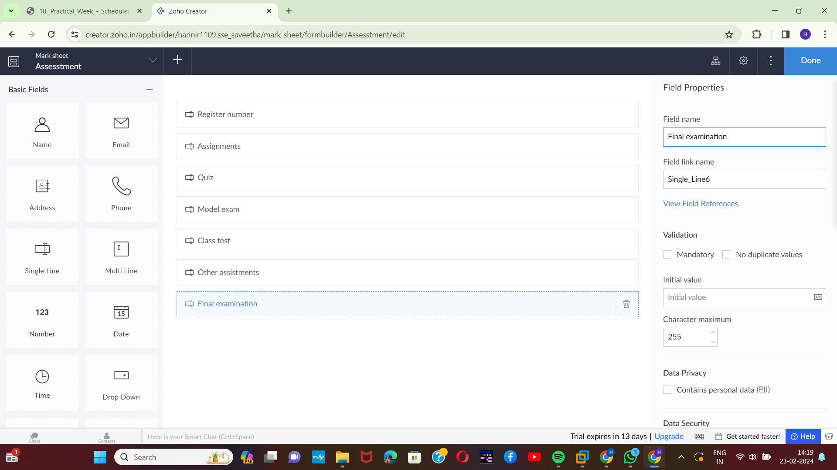

STEP-4:

Execute or run the model and get the required assesstment details from live.

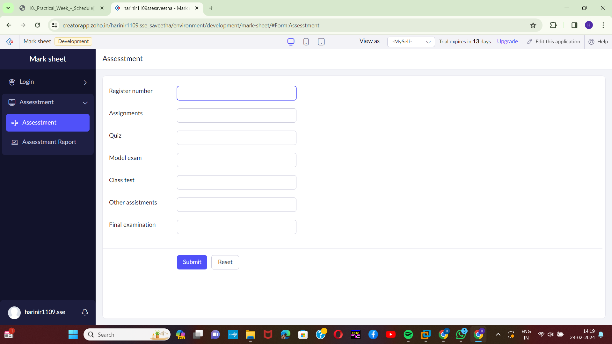[3]

STEP-5:

Next step is to add another form which consists of grade calculation with the fields.

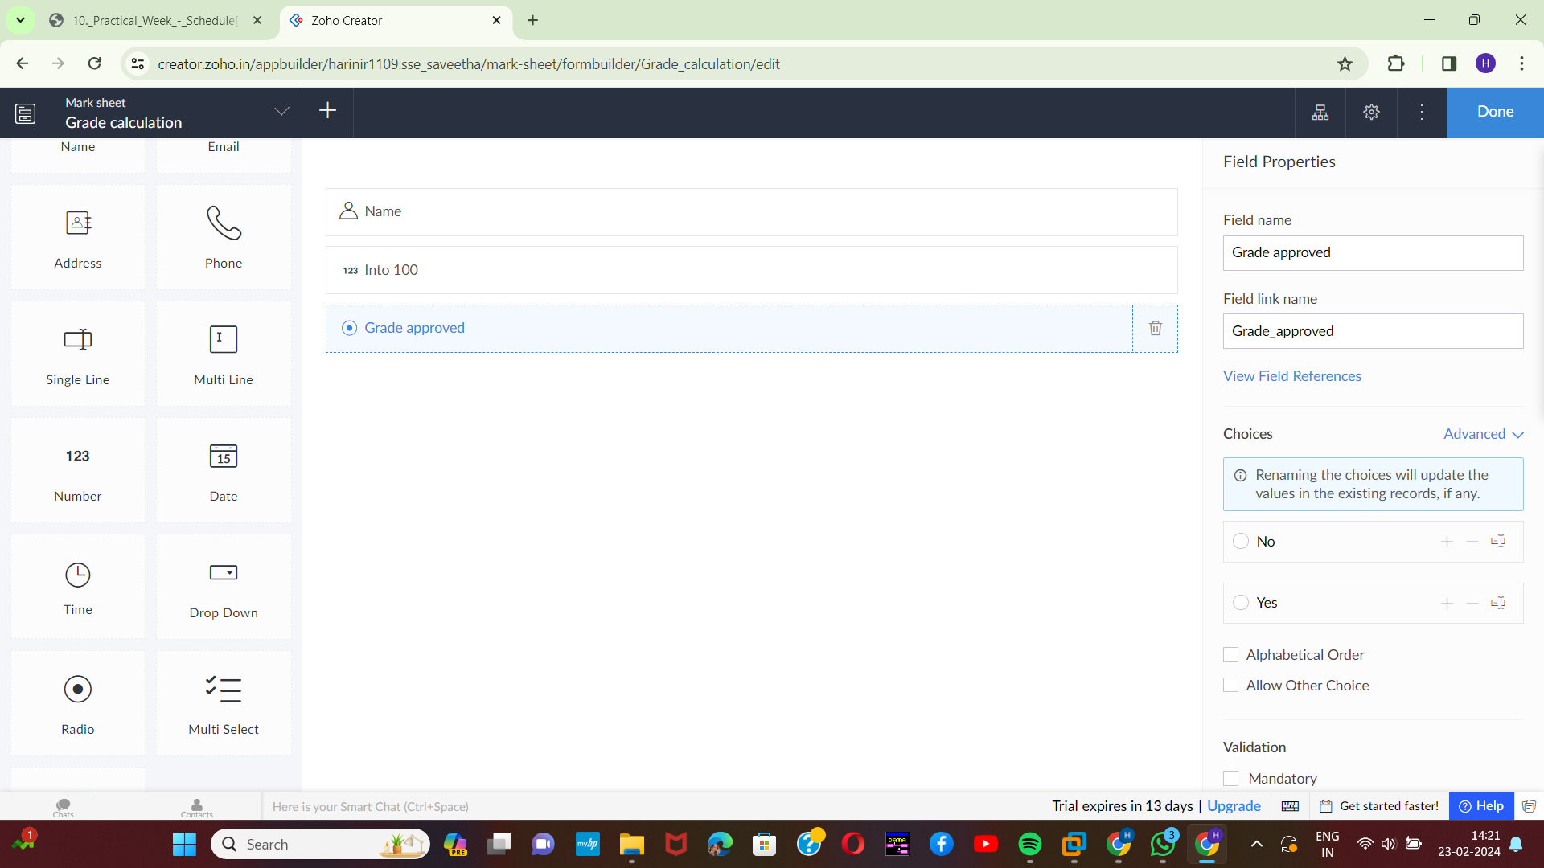[4]

STEP-6:

Execute or run the model and get the grade calculation details from live.

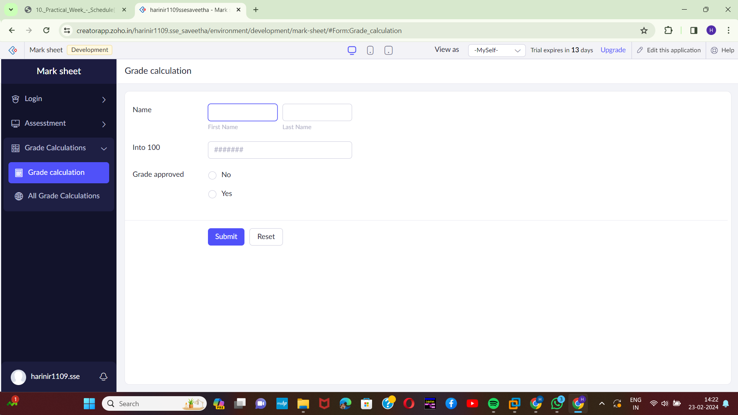

[5]

STEP-7:

Next step is to add another form which consists of logout details.

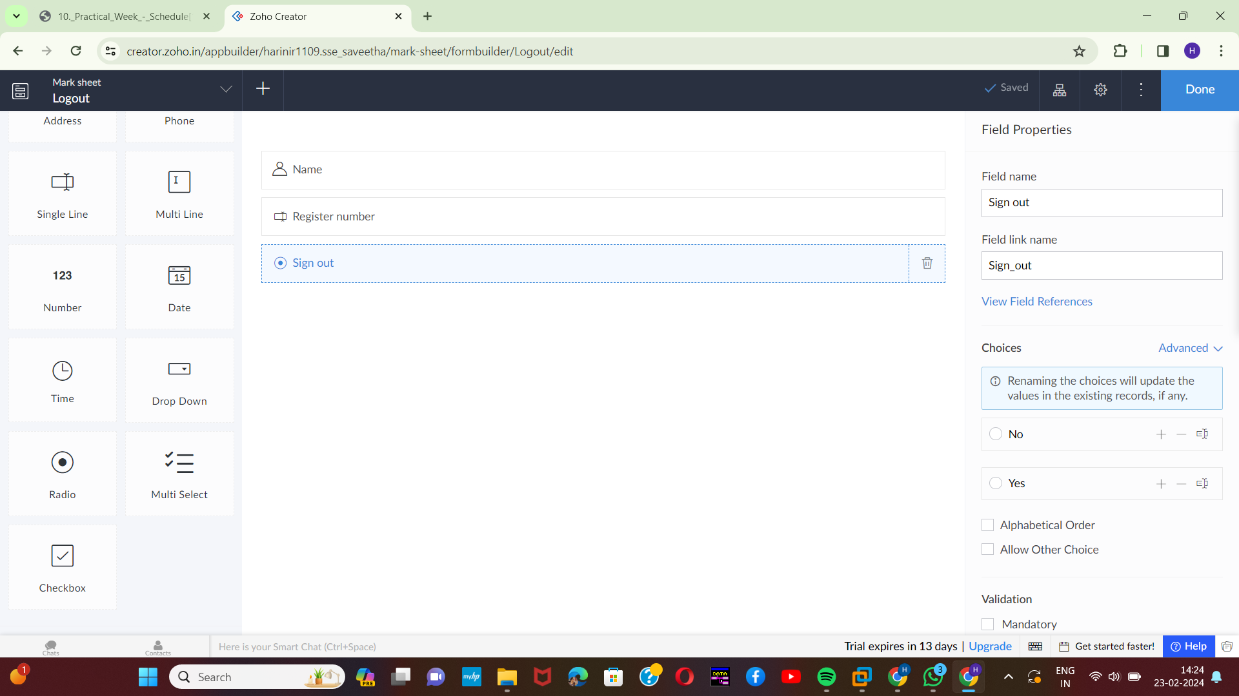

STEP-8:

The last step is to run and execute the logout details form and end the program.

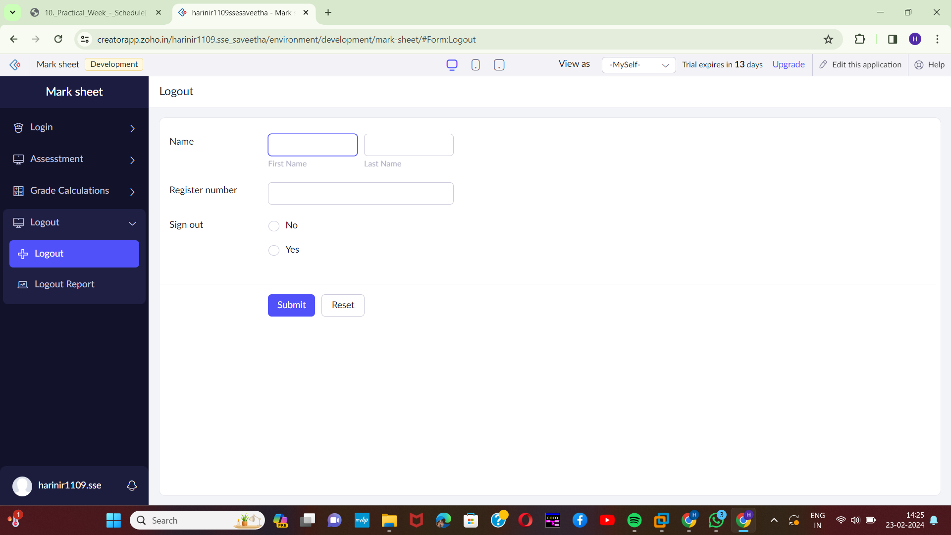[6]

.

1. Harini 192221109
2. Harini 192221109
3. Harini 192221109
4. Harini 192221109
5. Harini 192221109
6. Harini 192221109